Requirements General Description &

The goal of the database is to provide a system to manage and “old time” travel agency, allowing an easy access to all the services needed for a travel agaency , such as a hotel database , flights database , and vacation packages managed by the travel agency it self, as well as all of the bookings and the changes that are made to those bookings of the travelers.

General Description

The agent, will book trips for the traveler, a trip can consist of a flight , a hotel , a vacation package and a mix of all.

The traveler can access his bookings and view the info about them.

The agency system allows the agent to view all the flights and hotels the agency works with and the vacation packages that the agency offer.

The agents are responsible for registering new travelers to the system with all of they necessary info and the agent’s info is stored as well.

Each booking or trip is stored with the all the info about the services that were booked for that trip, whether it be several flights , several hotels or a vacation package that can consist of several flights and several hotels as well.

The ERD: 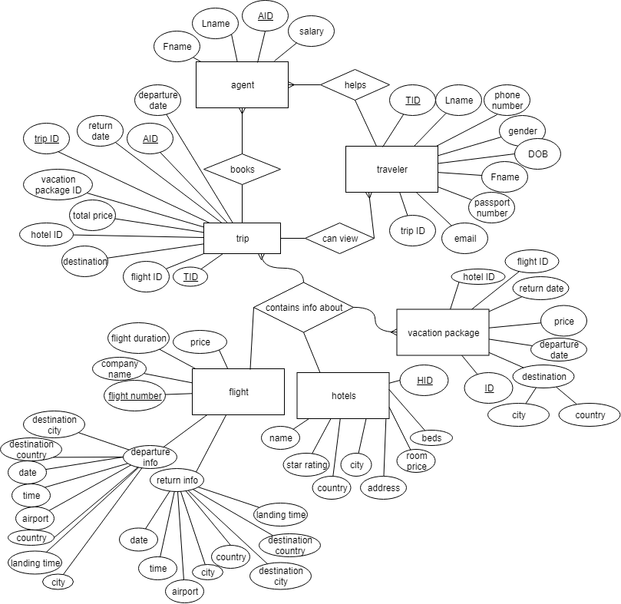

Physical representation of the Database:

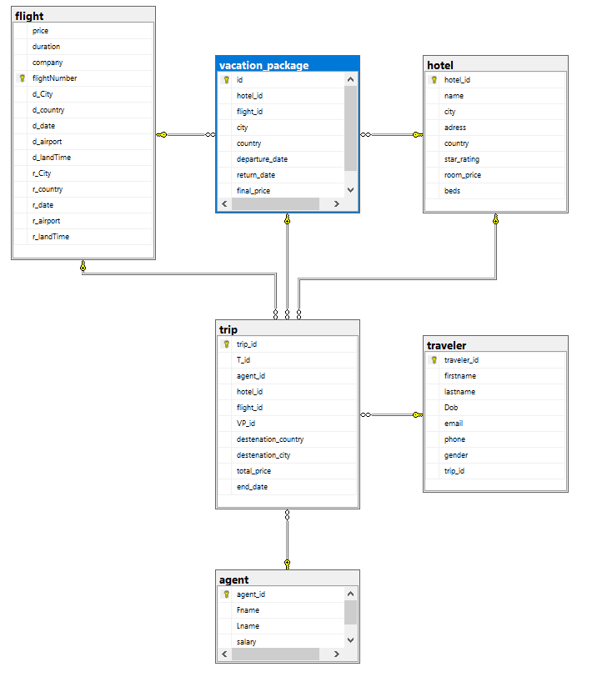

Two Users:

* Traveler- the customer, can request booking for hotels, flights , or vacation packages, he can see the pricing of all these services.

If his personal info changes, he can request a personal info update from the agent, can request to cancel booking and can view his itinerary of the trip/s he booked

* Agent- the agent is the main ser of the system.

He is the one booking the services for the traveler , flights , hotels or vacation packages.

He is responsible for maintaining the database to be as much updated as possible , if a traveler decides to no longer be a part of the database of the agency , he needs to delete him from the database, if a flight is updated , he needs to update it , if a hotel info changes he should update it and if a vacation package info changes he needs to update it.

Also, he receives salary ☺.

Database entities:

* **Traveler** - the customer, requests to book a hotel, flights, or a vacation package, his ID number ,first name , last name , phone number , gender , date of birth ,passport number ,email, and trip id(if existent) is stored in the database.
* **Agent** - does the work for the traveler if he is not able to book things on his own, plus is responsible for updating the database as needed for hotel, flights, vacation packages.

His first name, last name, employee ID, salary.

* **Flight** - one of the options for the traveler to book, it’s data is stored in the system database, flight company name, flight number , departure date and time, the airports initials, city and country, and the same info for the return flight, flight duration and ticket prices.
* **Hotel** - second option for the traveler to book, it’s data is also stored in the system database, the hotel’s ID, name , its star rating, the city it is based unaddressed in room and room prices.
* **Traveler** - the customer ,requests to book a hotel , flights ,or a vacation package. His ID number, first name , last name , phone number , gender , date of birth ,passport number, email, and trip id(if existent) is stored in the database.
* **Agent** - does the work for the traveler if he is not able to book things on his own , plus is responsible for updating the database as needed for hotel , flights , vacation packages.

His first name , last name , employee ID, salary .

* **Flight** - one of the options for the traveler to book , it’s data is stored in the system database, flight company name , flight number , departure date and time, the airports initials, city and country, and the same info for the return flight, flight duration and ticket prices.
* **Hotel** - second option for the traveler to book , it’s data is also stored in the system database, the hotel’s ID, name , its star rating, the city it is based unaddressed in room and room prices.

Relationships:

The **agent** helps the **traveler** andbook services for him, the **traveler** than have access to his **trip** info, whether it be a **hotel**, **flight** or **vacation package**.

The **agent** can add/remove **travelers** from the database, and can see his(traveler) required info.

The **vacation package** contains info about **hotel** and **flights** .

**Hotels** are located in certain **cities , flights** leave from certain **cities** and land in other **cities.**

**Flights** and **hotels** have a relationship with the **city** entity,each **flight** has its departure and arrival **city**, while hotels are linked to city location